Signage requirements
2.5 Duty of PCBU to display signage: general duty
- This regulation applies to a workplace where—
    - quantities of a hazardous substance with a hazard classification specified in the first column of the table in Schedule 3 and in a form specified in the second column of that table, that exceed the quantity specified for that classification in the third column of that table are present; or
    - more than 50 kg of LPG, propane, butane, or isobutane is present within a building: or
    - any quantity of LPG, propane, butane, isobutane, or other flammable gas refrigerant is present in an integral part of a refrigeration system that is contained in a machinery room as defined in AS/NZS 5149.1: 2016, AS/NZS 5149.2: 2016, AS/NZS 5149.3: 2016, and AS/NZS 5149.4: 2016—Refrigerating systems and heat pumps—Safety and environmental requirements; or
    - more than 250 kg of LPG, propane, butane, or isobutane is present in a place other than a building.
- The PCBU with management or control of the workplace must ensure that— (a) the signage required by regulation 2.6 is displayed; and
    - the content, presentation, and positioning of the signage comply with that regulation; and
    - the signage meets the following requirements for comprehensibility, clarity, and durability:
      - the signage is in English:
      - the signage is readily understandable:
      - abbreviations and acronyms are not used unless they are in common English usage and the term described by the abbreviation or acronym is used at least once on the signage:
      - all required information is clearly visible and legible at a distance of not less than 10 m under varying conditions (for example, rain or poor light):
      - the signage is made of materials that are durable, are resistant to sunlight, and require minimal maintenance.
(2A) This regulation applies to a hazardous substance referred to in—
    - regulation 2.7 (transit depots) only to the extent set out in regulation 2.7(1)(b):
    - regulation 2.9 (milking animals) only to the extent set out in regulation 2.9(1)(b).
- Subclause (1)(a) does not apply to anhydrous ammonia that is contained in plant in which anhydrous ammonia is used as a refrigerant.
- Subclause (2)(c)(iv) does not apply to signage at a service station where E10, E85, petrol, or diesel is stored for the refuelling of vehicles of the general public if the signs are clearly visible and legible at the point of refuelling.
- A person who contravenes this regulation commits an offence and is liable on conviction,—
    - for an individual, to a fine not exceeding $6,000:
    - for any other person, to a fine not exceeding $30,000.

2.6 Signage requirements for general duty
- For the purposes of regulation 2.5, if a hazardous substance is located in a building at a workplace, but is not confined to a particular room or compartment within the building, the PCBU with management or control of the workplace must ensure that there is positioned at every vehicular and pedestrian entrance to the building and the land on which the building is located signage—
  - stating that hazardous substances are present; and
  - stating the general type of hazard of each of them; and
  - describing the immediate response action to be taken in an emergency.
- Despite subclause (1), if the hazardous substance is a class 1 substance, the PCBU must ensure that signage that complies with paragraphs (a) to (c) of that subclause is positioned—
  - at every vehicular and pedestrian entrance to the building; and
  - at every approach to the building that is within the boundary of the land where the building is located and that emergency services organisations may use.
- If hazardous substances are located in a particular room or compartment within the building, the PCBU with management or control of the workplace must ensure that signage that complies with subclause (5) is positioned at each entrance to the room or compartment.
- If hazardous substances are located in an outdoor area, the PCBU with management or control of the workplace must ensure that signage that complies with subclause (5) is positioned immediately next to that area.
- The signage required by subclauses (3) and (4) must—
  - contain—
    - the word EXPLOSIVES in relation to class 1 substances; or
    - the word HAZCHEM in relation to class 2, 3, 4, 5, 6, or 8 substances; and
  - state the hazardous properties and describe the general type of hazard relating to each category of hazardous substance present through the use of—
    - hazard pictograms consistent with the correct classification of the hazardous substances present; or
    - hazard statements consistent with the correct classification of the hazardous substances present; and
  - describe,—
    - if the substances include explosive substances, the precautions necessary to prevent unintended explosion of an explosive substance; and
    - if the substances include flammable substances, the precautions necessary to prevent unintended ignition of a substance; and
    - if the substances include oxidising substances or organic peroxides, the precautions necessary to prevent unintended combustion of, acceleration of a fire from, or thermal decomposition of, an oxidising substance or organic peroxide; and
  - describe the immediate response action to be taken in an emergency.
- Subclause (4) does not apply if the hazardous substance is class 6.1A, 6.1B, 6.1C, or 6.1D vertebrate toxic agents or agrichemicals at a temporary storage site.

Example
The following are examples of temporary storage sites:
- a temporary field bait handling site:
- an aircraft loading site.

2.10 Duty of PCBU to maintain signage
- A PCBU who is required to display signage must—
  - alter the signage as soon as practicable if a change in the type, class, or quantity of hazardous substances present at the workplace requires different information to be displayed; and (b) ensure that the signage is—
    - kept clean; and
    - maintained in good repair; and (iii) not covered or obscured.
- A PCBU who contravenes this regulation commits an offence and is liable on conviction,—
  - for an individual, to a fine not exceeding $6,000:
  - for any other person, to a fine not exceeding $30,000.

Examples of Signage:

Gate Signage:
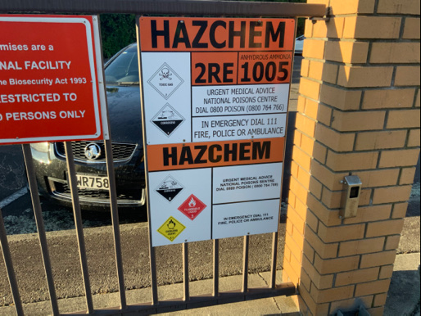

Outside Area/Dedicated Room Signage:
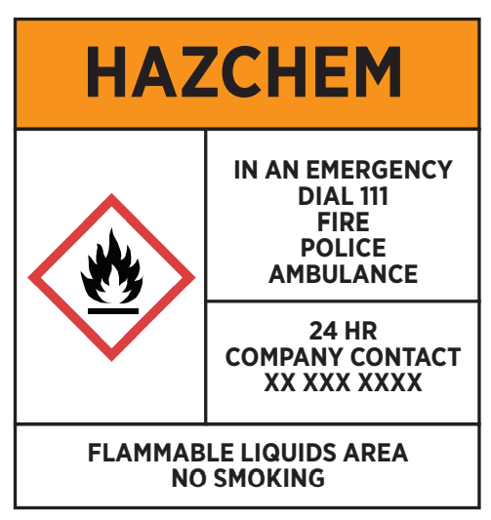
Inside Area (Non-Dedicated Room) Signage:

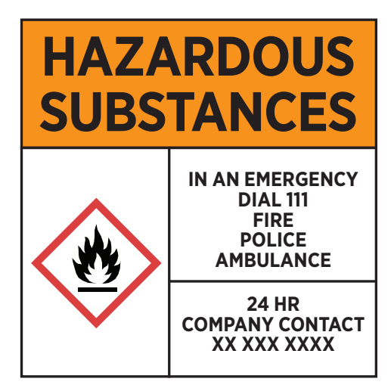

Storage Tank Signage:

